**APPROACH FOR THE MODEL BUILDING:**

1. DATA SCRAPING:

* Used python based selenium webdriver script to harvest data for the given parameters.
* Collected the harvested data into a mongodb database (json based db).
* Exported the csv format data and imported into code processing.

1.1 DATA CLEANING AND PREPROCESSING:

* Removed the Null/absent data values from the following essential features:
  + Budget
  + Cumulative worlwide Gross
  + Gross USA
  + 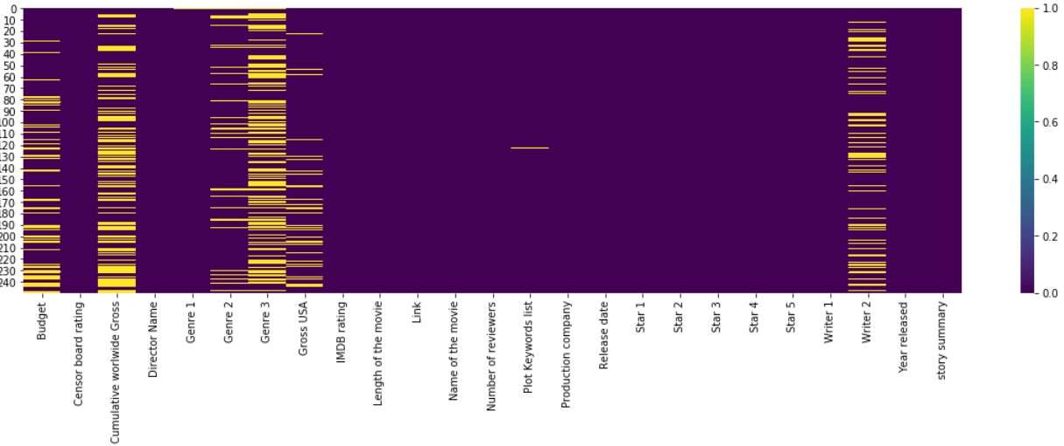

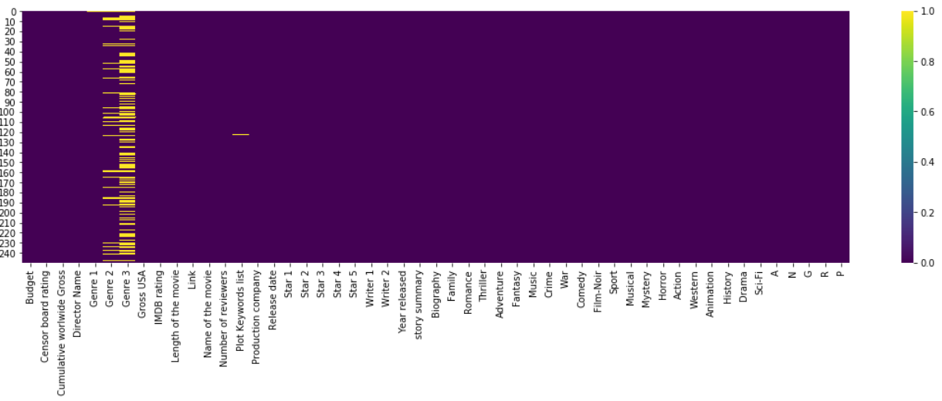

* Textual cleaning in the following features:
* Writer 2
* Censor board rating
* Number of Reviewers
* Rectification/Replacement in the following feature:
  + Censor board rating
  + 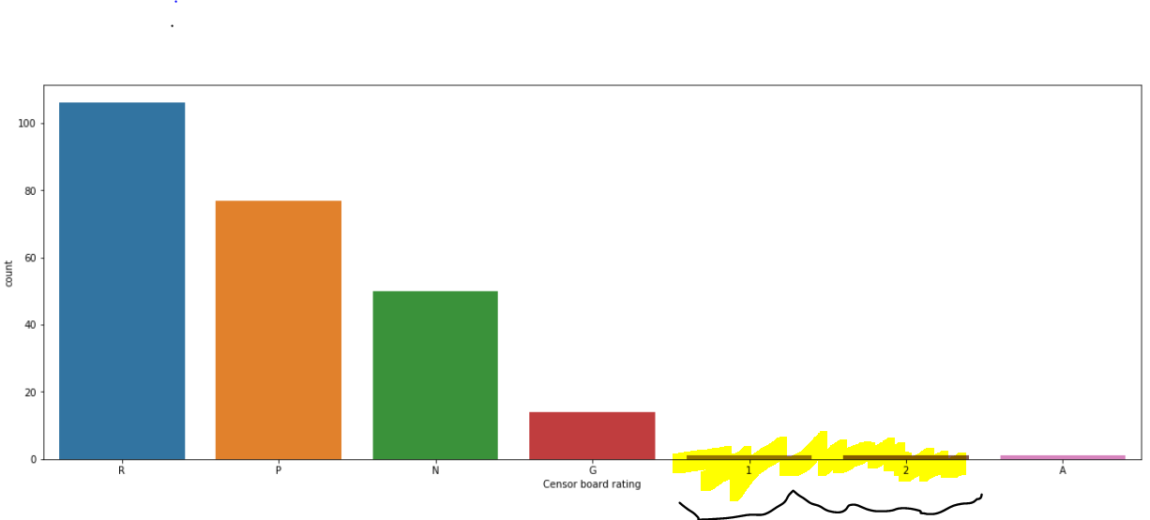
* Allocating appropriate data types to following essential features:
  + Budget (float)
  + Cumulative worlwide Gross (float)
  + Gross USA (float)
  + IMDB rating (float)
  + Number of reviewers (int)
* Feature extraction/encoding as separate features for the following:
  + Genre 1
  + Genre 2
  + Genre 3
  + Censor board rating
  + 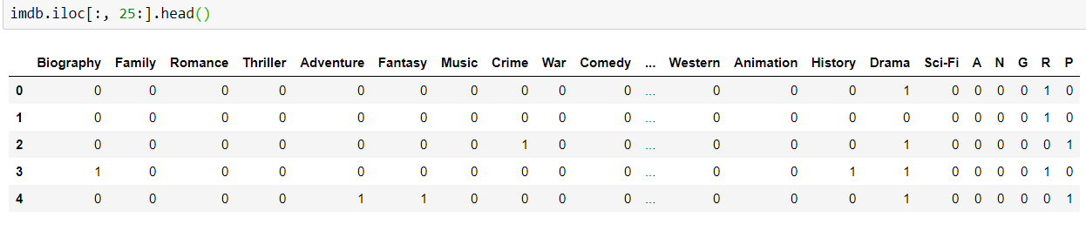

2. MODEL BUILDING:

* Input features:
* 'Budget', 'Cumulative worlwide Gross',
* 'Gross USA',
* 'Number of reviewers',
* 'Biography', 'Family', 'Romance', 'Thriller', 'Adventure', 'Fantasy', 'Music',
* 'Crime', 'War', 'Comedy', 'Film-Noir', 'Sport', 'Musical', 'Mystery',
* 'Horror', 'Action', 'Western', 'Animation', 'History', 'Drama','Sci-Fi',
* 'A', 'N', 'G', 'R', 'P'
* To predict:
  + 'IMDB rating'
* Splitting the dataset:
  + 80% train
  + 20% test

* Using Linear Regression model since other models such as Decision Trees and SVM tend to over fit on small datasets
* Evaluating the model on test set with MAPE to 1.7%
* Cross Validating (cv=10) the model to find model overfitting or underfitting
* The model has optimal bias variance tradeoff